Chapter 11, Solution 75.

Consider the power system shown in Fig. 11.90. Calculate:
(a) the total complex power
(b) the power factor
(c) the capacitance necessary to establish a unity power factor

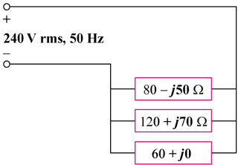

Ω

Figure 11.90
For Prob. 11.75.

Solution

= (1.8359 – j0.11468) kVA

{leading}

- Since the circuit already has a leading power factor, near unity, no compensation is necessary.

